YEAR 12 PHYSICS
TOPIC TEST 2, 2021
TASK 3 WEIGHTING: 6%
GRAVITY, SATELLITES AND STATIC EQUILIBRIUM

STUDENT NAME: _______________________________________

CLASS: ATPHY _ MARKS: ________/45

TEACHER: _____________________________

- Answer all questions.
- Show all working.
- When calculating numerical answers, show your working or reasoning clearly.

- Give final answers to three significant figures and include appropriate units.
- When estimating numerical answers, show your working or reasoning clearly. Give final answers to a maximum of two significant figures and include appropriate units.

1. (4 marks)

Satellites orbiting freely around the Earth are sometimes placed in equatorial orbits (diagram A) and sometimes in polar orbits (diagram B). Explain why the orbits in diagram C are physically impossible for satellites.

--------------------------------------------------------------------------------------------------------------------------------------------------------------------------------------------------------------------------------------------------------------------------------------------------------------------------------------------------------------------------------------------------------------------------------------------------------------------------------------------------------------------------------------------------------------------------------------------------------------------------------------------------------------------------------------------------------------------------------------------------------------------------------------------------------------------------------------------------------------------------------------------------------------------------------

2. (4 marks)

A tradesperson leans a ladder against the gutter of a house and is careful to make the angle between the ground and the ladder as large as practical.

LADDER
ROOF

- Use arrows to show all the forces on the ladder in the diagram below. (2 marks)

- If the angle ɵ is increased, how is the reaction from the ground affected? Explain your answer. (2 marks)

------------------------------------------------------------------------------------------------------------------------------------------------------------------------------------------------------------------------------------------------------------------------------------------------------------------------------------------------------------------------------------------------------------------------------------------------------------------------------------------------------------------------------------------------------------------------------------------------------------------------------------------------------------------------------------------------

3. Suppose that in the future, as a way to combat global warming, the Earth was moved to a new orbit with a mean radius 5.00% larger than the current one. How many more days would the Earth take to orbit the Sun in this new orbit? (4 marks)

4. (5 marks)

The diagram below represents the human shoulder joint and the attached arm(courtesy Mr Taylor). The shoulder joint has the deltoid muscle connected to the humerus, a bone in the upper arm around 15 cm from the shoulder joint. The arm has a mass of 3.50 kg.
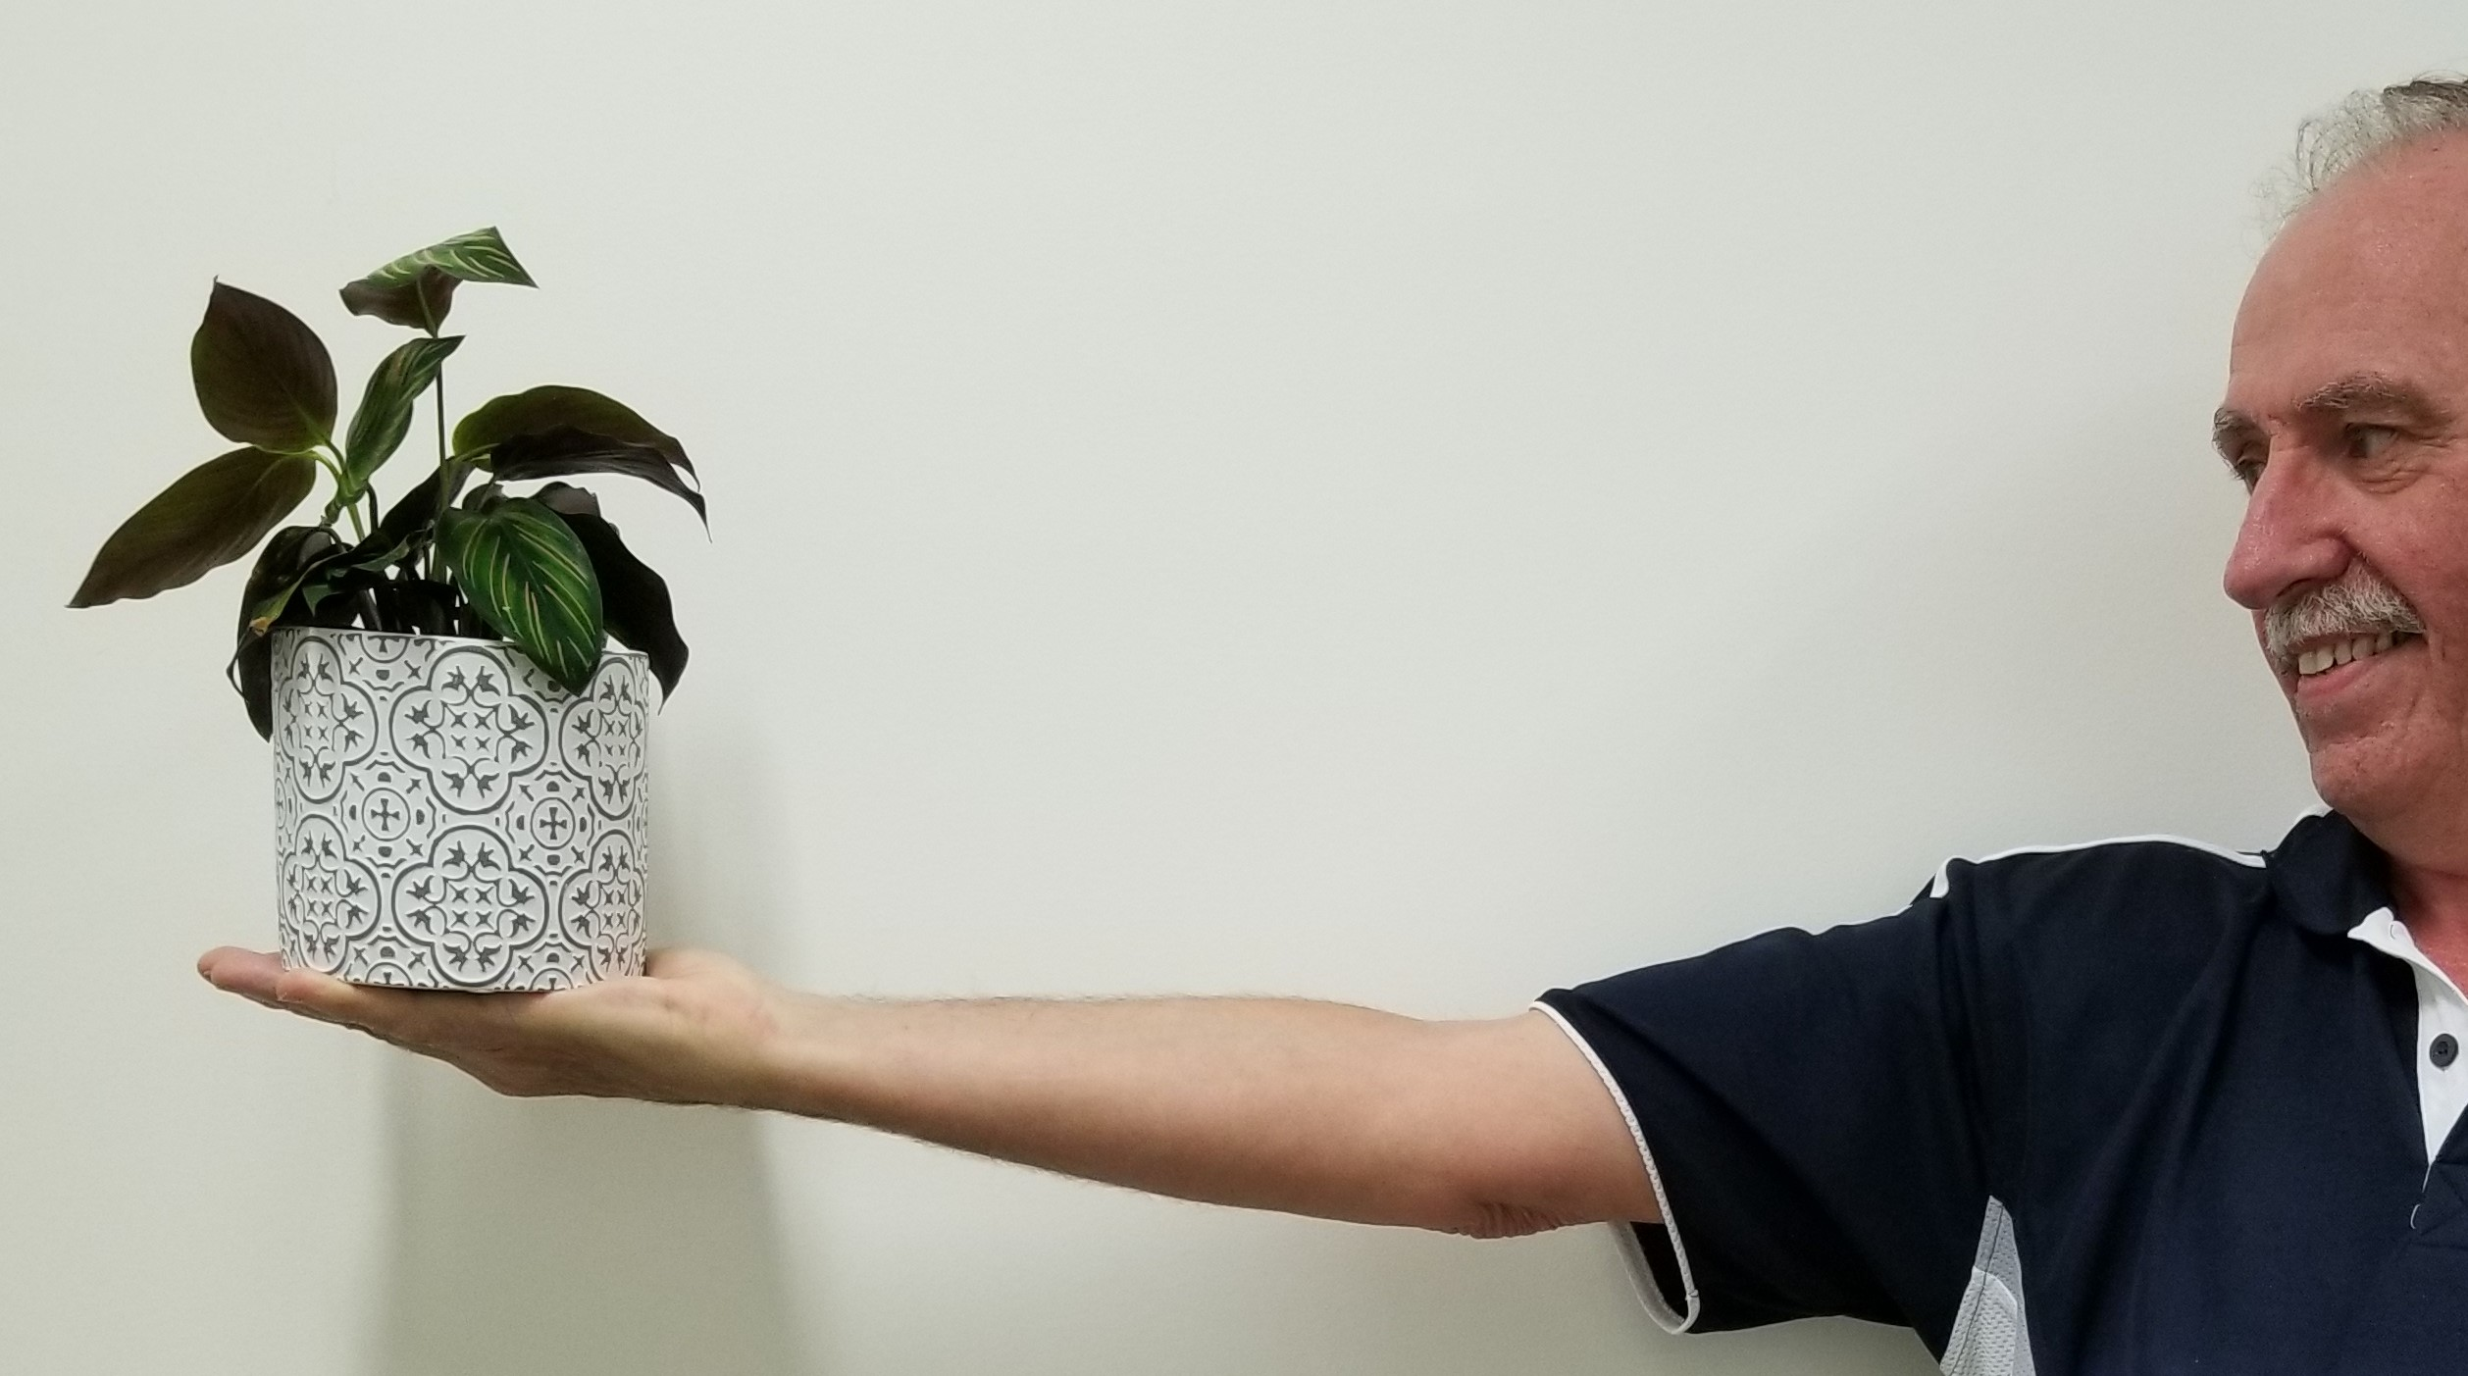

Deltoid muscle

15^{O}

0.64m 0.19m 0.15m

LOAD ARM WEIGHT

a) If the arm and shoulder are in a state of static equilibrium, what conditions must be met? (2 marks)

----------------------------------------------------------------------------------------------------------------------------------------------------------------------------------------------------------------------------------------------------------------------------------------------------------------------------------------------------------------------------------------------------------------------------------------------------------------
----------------------------------------------------------------------------------------------------------------
b) Calculate the tension in the deltoid muscle when a 2.00 kg flower pot (the load) is held in the hand with the arm outstretched. (3 marks)

5. (15 marks)
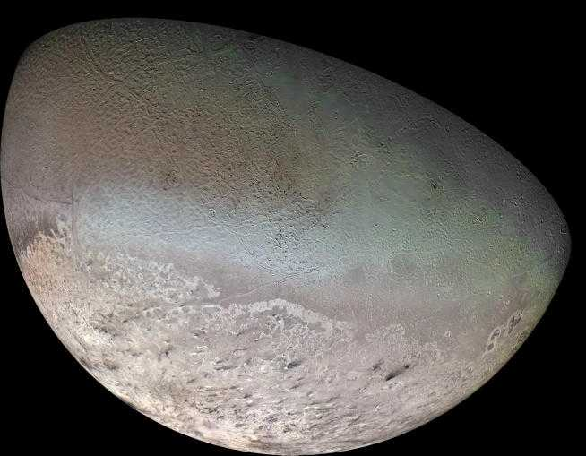

The planet Neptune has eight moons, one of which is called Triton. Inside a spacecraft at rest on Triton’s surface is a 10.0 kg mass hanging from a spring balance. The spring balance measures force in Newtons.

Mass of Triton = 2.14 x 10²³ kg
Radius of Triton = 1.35 x 10⁶ m
Mass of spacecraft = 2.00 x 10³ kg
Radius of Triton’s orbit around Neptune = 3.53 x 10⁸ m

- What is the reading on the spring balance in Newtons? (3 marks)

Mass of Triton = 2.14 x 10²³ kg
Radius of Triton = 1.35 x 10⁶ m
Mass of spacecraft = 2.00 x 10³ kg
Radius of Triton’s orbit around Neptune = 3.53 x 10⁸ m

The spacecraft takes off and is now in circular motion around Triton, at an altitude of 2.70 x 10⁶ m.
b) What is the gravitational field strength at this altitude due to Triton? (3 marks)

c) Another moon of Neptune is Nereid, which orbits at a distance of 5.50 x 10⁹ m from Neptune’s centre. Nereid takes 360 days to orbit Neptune. Determine the mass of Neptune. (4 marks)

d) When Neptune is in position Z (not drawn to scale), what is the net gravitational force that the spacecraft experiences? (5 marks)

6. (13 marks)
A metal structure, ABCD, is used as part of a crane to lift a heavy load. It is hinged at the wall at A and is supported by a steel cable attached to a point X, 6.45 m above the hinge. The angle between the cable and the wall is 37º. The weight of ABCD is 950 N. A load of 154 kg is being lifted at C. Other dimensions are: AD = 2.50 m, DC = 2.50 m, BD = 1.50 m.
- Calculate the tension the cable. (4 marks)

- Calculate the magnitude of the reaction force of the wall on the structure at A. (6 marks)

- Determine the direction of the reaction force of the wall on the structure at A. (3 marks)

